A3. Looping and Branching

# Expected Output

Note that in this block you have many combinations of possible inputs. Below is just an example. You are strongly encouraged to check out different combinations on graph choice to test out your loops and branches.

Sample run No:1

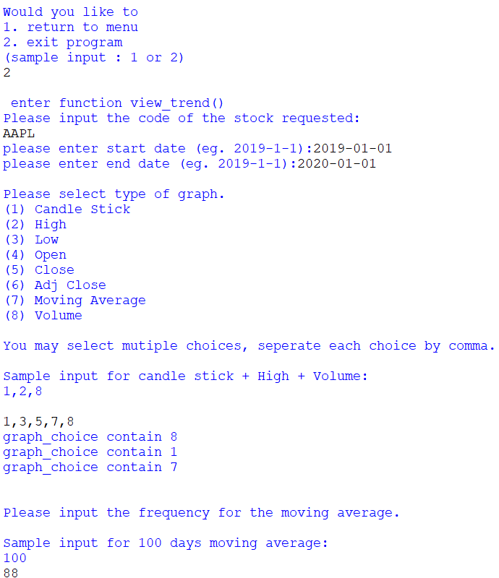

Sample run No:2

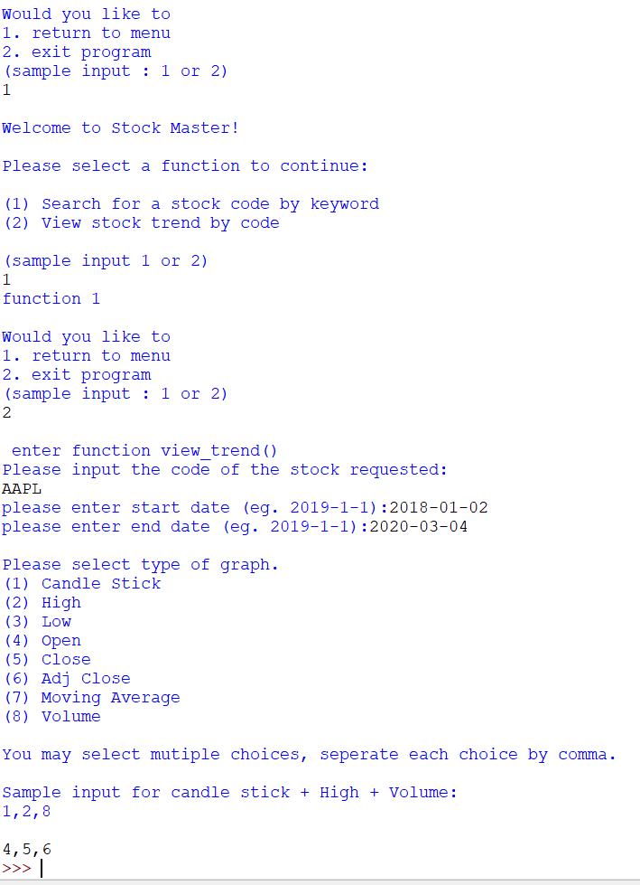

Sample run No:3:

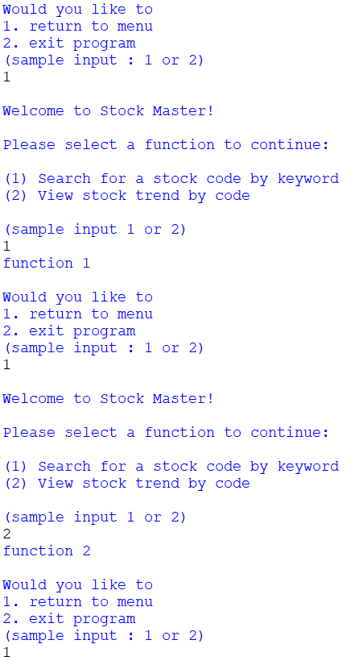

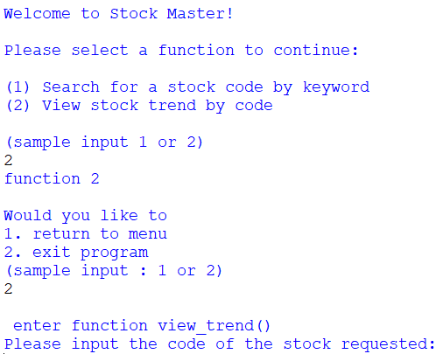

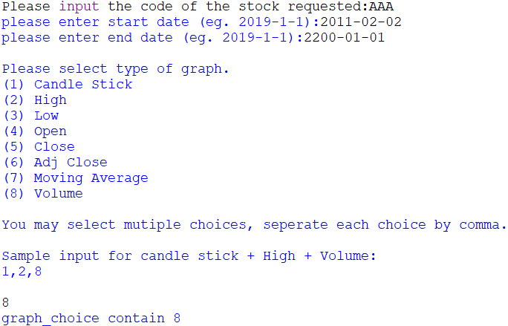

Sample run No.4:

